Wood density in relation to hydraulic conductivity and vessels across species

K. L. Hughes and M. Westoby

Department of Biological Sciences, Macquarie University, Sydney, NSW 2109, Australia

Author for correspondence:
Kathryn Hughes
klhughes@bio.mq.edu.au
Department of Chemistry and Biomolecular Sciences, Macquarie University, NSW 2109, Australia

Running headline: Wood density and water flow

SUMMARY

1. Water transport and wood density are linked. We examined vessel anatomical characteristics, wood density and theoretical conductivity in 48 woody angiosperms, chosen to allow comparison within sites and also across rainfall and soil nutrient contrasts.

2. If lower wood density were an indicator of more or larger vessels, then wood density should be a predictor of conductivity. It proved weakly (r² = 0.21) correlated across all species, but this correlation was produced by differences across sites rather than across species within sites.

3. Across species within sites, increase in hydraulically-weighted mean vessel diameter (d_{hw}) outweighed correlated decrease in vessel density (VD), such that species with high conductivity were characterized by larger but fewer vessels. There was no tendency for high-conductivity species to have a larger fraction of the xylem cross-section as vessel lumen.

4. Between sites, species living at high rainfall tended to have higher VD but similar d_{hw}. Therefore they tended to have higher conductivity and greater fraction lumen. Differences were not substantial between species on higher versus lower nutrient soils.

5. The fraction of a cross-section that was not vessel lumen was correlated with wood density, but the main influence on wood density was the density rather than the amount of this non-lumen fraction. Similarly, the proportion of spaces within non-lumen was correlated with lower density of the non-lumen fraction, but the main influence on density of the non-lumen fraction was the density of the solid part.

6. Thus species with a larger fraction of the cross-section as vessel lumen also tended to have lower density tissue outside the lumen. This coordination might prove to be an important factor in trade-offs surrounding wood density and conductivity, and so the adaptive basis for it deserves investigation.

INTRODUCTION

Natural selection has shaped the stem vasculature through which water is transported from soil to leaves (Fig. 1). There are advantages and disadvantages of large versus small or few versus numerous vessels, depending on the environment a plant exists in. Larger vessels provide much less resistance to water flow, as conductivity along the lumen of a vessel scales to the fourth power of vessel diameter by the Hagen-Poiseuille principle. However, larger vessels also cavitate first, producing faster decline in conductivity along the stem, and incurring costs in refilling that are not well understood. Higher vessel densities provide the potential for more water flow (Fig. 1) and contribute alternative pathways should cavitation occur.

One variable with a theoretical connection to stem vasculature is wood density. It is a variable which encapsulates much information about the structure of a stem, and what tissues make it up. Wood density can be thought of as composed of the solid wood that surrounds vessels, plus the open space in vessel lumens, that has zero density (Fig. 1). On this basis, the overall wood density would be expected to decrease where a larger proportion of the cross-section was vessel lumens. Given the relationship between vessel size and water flow, conductivity would also be expected to be negatively related to wood density; several studies have reported such a correlation (Wagner, Ewers and Davis 1998; Bucci et al. 2004; Santiago et al. 2004). In addition, a number of studies have found that wood density was loosely correlated to leaf size, such that the stems of large-leaved plants tended to have wood of lower density than small-leaved plants (Ackerly 2004a; Cavender-Bares, Kitajima and Bazzaz 2004; Pickup, Westoby and Basden 2005; Rossetto and Kooyman 2005; Wright et al. 2006a). Species with larger leaves tended also to deploy more leaf beyond a given sapwood cross-section (Wright et al. 2006b). On this basis Wright et al. (2006a) and Wright et al. (2006b) suggested the lower wood density might reflect a larger fraction of the cross-section being lumen, in order to supply the transpiration stream of a larger amount of leaf.

Our aim was to quantify, both across environmental contrasts and within sites, how between-species differences in twig conductivity and anatomy related to wood density. We worked with a quantity known as "theoretical conductivity" (Fig. 1), which is calculated using the Hagen-Poiseuille principle from the number of vessels and their diameters measured in a cross-section of sapwood (Gorsuch, Oberbauer and Fisher 2001; Phillips, Bond and Ryan 2001; Tyree and Zimmermann 2002; Corcuera, Camarero and Gil-Pelegrin 2004). Theoretical conductivity will be greater than conductivity measured directly by passing water along a stem, because it does not account for resistance passing through pits from one vessel into another. Still, it reflects accurately the influence of the frequency distribution of vessel sizes on conductivity.

The present study aimed first to check whether low wood density was an indicator of high conductivity as expected, across 48 species from high and low rainfall environments (Fig. 1). Behind that expected relationship, we aimed to investigate how vessel sizes and numbers influenced both wood density and theoretical conductivities (Fig. 1).

MATERIALS AND METHODS

Study sites
Species were sampled during 2004 and 2005 from four sites (Table 1) used also by Pickup et al. 2005. Two sites at contrasted soil nutrient levels were in a high rainfall zone (Strickland State Forest, on the New South Wales central coast) and another pair of sites in a low rainfall zone (Round Hill Nature Reserve, central–western N.S.W).

Wood samples
The plant species used (listed in Table 2) were the most abundant at each site. In order to obtain comparable twigs across species, a xylem conductive area of 10 mm² and a twig containing this area (4-5 mm over-bark diameter) was taken from four individuals of each species, from a branch in full sunlight from the upper canopy. The twigs were stored in airtight plastic bags, transported to the lab in a cooler, refrigerated and processed, usually within 72 h of collection.

Xylem anatomy
Transverse sections of the twigs 30-50 μm thick were cut with a sliding microtome at a conductive cross-sectional area of 10 mm² and stained with toluidine blue. Micrographs of a representative cross-section for each plant were taken using a CCD video camera attached to a light microscope. At least four radial sectors approximately equally-spaced around the circumference of the twig were imaged at 100X magnification. The radial boundaries of sectors were defined by the middle of parenchyma rays to ensure appropriate representation of age classes of vessels within each sector and of contribution of rays to the stem. Inner and outer boundaries of radial sectors were defined by the pith and the vascular cambium.

Open spaces with major diameter less than 10 μm were treated not as vessel lumen but rather assumed to be fibre lumen or other non-vessel lumen (as in Corcuera et al. 2004). Due to conductivity being proportional to the fourth power of conduit radius, even if any of these spaces below the 10 μm cutoff had actually been vessels, their contribution to hydraulic conductivity would have been negligible. All open vessels in the cross-section were treated as capable of conducting water, which is reasonable given the young age of the twigs.

Using ImageJ software (v1.32j, NIH, USA), three image-analysis steps were undertaken for each sector. First the total area of the sector was measured (“sector area”). Next, the total area not in cell wall was measured (“area of space”); this included fibre and tracheid lumens as well as vessel lumens, and any empty parenchyma cells. Finally, we measured the total area of vessels (“vessel lumen area”) and dimensions of individual vessels. Although some species had very low vessel densities, usually a minimum of 200 vessels per cross section were measured.

Wood density
The wood density (dry mass per fresh volume) of a 2.5 cm segment of the twig adjacent to where the section had been cut was obtained following the method described in Hacke, Sperry and Pittermann (2000).

Calculated parameters
We calculated a quantity known as theoretical conductivity. This integrates the influence of vessel numbers and sizes on the conductivity of a stem, though it does not account for resistances through pits passing from one vessel to the next. Conductivity (potential hydraulic flow, J, across unit pressure gradient) was calculated for each individual vessel assuming elliptical vessel cross-sections after Lewis and Boose (1995):

π a³b³
J = 64η a² + b²

where a and b are the major and minor vessel diameters, η is the viscosity of water. The sum of J for all measured vessels of a particular individual, when divided by the sum of the relevant sector areas, gave a xylem-specific theoretical conductivity (k_{t}) for that individual plant.

A hydraulically-weighted mean vessel diameter (d_{hw}) was calculated as

d_{hw} = 2 (Σr⁴/n)^{1/4}

following Ackerly (2004b), where r is the geometric mean of the major and minor vessel diameters, and n is the number of vessels measured in that sector.

Estimated density of non-vessel lumen was found by dividing the wood density by (1 – fraction vessel lumen). Similarly, estimated density of solid material within the non-lumen fraction (“estimated density of non-space”) was found by dividing wood density by (1 – fraction space).

Data analysis:
Pairwise Pearson correlation coefficients were calculated within the program SPSS. Bivariate trait relationships were analysed by fitting Standardised Major Axis (SMA) lines to the variables (SMATR program; Warton et al. 2006).

RESULTS

Wood density and hydraulic conductivity

Across both species and sites, wood density was a predictor of conductivity; however, the correlation was weak (Fig. 2, r² = 0.21, P < 0.01; full set of correlations in Table 3). The correlation was predominantly caused by some species from the high-rainfall, high-nutrient site which had both higher conductivity and lower wood density (Fig. 2).

The basis for expecting a relationship between lower wood density and higher conductivity is that more or larger vessels would correspond to a larger lumen fraction, that is to a smaller non-lumen fraction and to a lower density. Therefore, we next investigated how this expected relationship came to be so weak, by examining the relationships between wood density and the other measured stem properties (Fig. 1).

Initially, we looked at vessel anatomy. As expected, the proportion of the cross-section that was vessel lumen was correlated with low wood density (Fig. 3), especially across all species (r² = 0.56, P < 0.01) but also to a certain extent within sites. However, the fraction that was lumen varied only from about 3% to 15% of the cross-section, while wood density varied more than twofold, from 1.0 to less than 0.5.

Variation in the fraction that was lumen therefore could not have been the main cause of variation in wood density. Rather, wood density varied mainly in response to density of the fraction of the cross-section that was not vessel lumen (r² = 0.99, P < 0.01; Fig. 4).

The estimated density of non-lumen material was correlated with the amount of space in that material (Fig. 5, r² = 0.43, P < 0.01). But similar to the situation for total wood density, the absolute amount of space in the non-lumen fraction ranged only from 0-6% (Fig. 5), far too little to explain the variation in density of non-lumen material.

In summary, while wood density was associated with non-lumen fraction, that association was driven mainly by differences between high-rainfall and low-rainfall species; importantly, the association occurred mainly because non-lumen fraction was correlated with the density of non-lumen fraction (Fig 6), rather than through direct effects of having more or less lumen.

. Interestingly, density of the non-lumen tissue was more closely correlated with lumen fraction, that is with the maximum volume of water held in vessels per volume of sapwood at a point in time (r² = 0.46, Table 3), than with the theoretical conductivity, that is with the maximum volume of water moving through a volume of sapwood per unit of time (r² = 0.18, Table 3).

How do vessel characteristics combine to influence theoretical conductivity?

Theoretical hydraulic conductivity is proportional to vessel density multiplied by hydraulically-weighted vessel diameter to the fourth power. Therefore on a log-log graph of vessel density versus hydraulically weighted diameter a line of slope -4 connects a set of alternative combinations that produce the same theoretical conductivity. On such a graph variation from left to right across the line of -4 slope represents increasing theoretical conductivity. A line of slope -2 shows the set of alternative diameter-density combinations that produce approximately the same fractional vessel area.

Comparing anatomical strategies within each of the four sites, increases in vessel diameters were correlated with decreasing vessel density (r² = 0.36, P < 0.01, Fig. 7). However, the decrease was shallower than the -4 slope that would correspond to conserving the theoretical conductivity. That is, variation in vessel diameter outweighed variation in vessel density. Species with larger but fewer vessels tended to have higher theoretical conductivity. The decrease in vessel density with increasing hydraulically-weighted diameter within sites was consistent with a slope of -2, indicating the fraction of cross-section occupied by vessels was not varying systematically across anatomical strategies within site.

Across sites, differences occurred more in the vessel density dimension, with high-rainfall sites tending to higher vessel density at a given hydraulically-weighted diameter, and correspondingly to a higher range of conductivity (Fig. 6). On average, species at low rainfall sites had about half the vessel density of species at high rainfall sites, and correspondingly about half the theoretical conductivity, since hydraulically-weighted mean vessel diameters were similar.

DISCUSSION

We began with the expectation that species with lower wood density would tend to have higher theoretical conductivity, because the vessels that contribute to water flow also contribute volumes of zero density to wood density measurements. Strong correlations had been reported between wood density and empirical measurements of conductivity (Stratton, Goldstein and Meinzer 2000, r² = 0.98; Bucci et al. 2004, r² = 0.9 and Santiago et al. 2004, r² = 0.65; although Gartner et al. 1990 did not find a correlation). Here we report a set of species where the correlation was weak, and absent across species within sites. Further, we have identified two main mechanisms that loosen the relationship. First, increasing vessel diameter tended to be associated with decreasing vessel density. This narrowed the variation in lumen fraction, especially within sites. But vessel diameter had a much stronger influence on conductivity than vessel density does, as expected from the fourth power relationship and as reported by a number of authors (e.g. Gartner et al. 1990, r² = 0.88 between vessel diameter and conductivity; Arnold and Mauseth 1999, r² = 0.89; Corcuera et al. 2004, r² = 0.52;). Thus conductivity was not tied to lumen fraction. Our results suggest species in each rainfall zone modulate vessel diameter and density to sit along lines of equal area in vessels, rather than the alternative, which is to modify their hydraulic architecture to reflect the annual supply of water and to sit along lines of equal conductivity.

Second, the main driver of wood density was not lumen fraction, but rather the estimated density of the non-lumen fraction. Several factors are expected to influence density of the non-lumen fraction, not least because wood density seems highly correlated to certain cell types (e.g. negatively to fibres, positively to axial parenchyma) and less correlated to others (vessels) (Fujiwara et al. 1991; MacDonald et al. 1995). Thicker vessel walls also can lead to higher wood density, and are favoured as a defense against xylem implosion under strong negative pressures (Hacke et al. 2001),.

Sapwood capacitance has been found to correlate strongly with sapwood-area-corrected hydraulic conductivity (Meinzer et al. 2003), but in our results, low density of the non-lumen wood fraction (which may reflect high capacitance) was correlated with large lumen fraction better than with high theoretical conductivity. Plainly, the adaptive and mechanistic trade-offs surrounding wood density and conductivity are still not very well understood. They deserve continuing attention, because of the importance of these traits for strategies in water use, height gain and mechanical strength.

ACKNOWLEDGMENTS
This work was funded by an Australian Research Council grant to Westoby. We thank Barbara Rice for help in the field, Amy Zanne and Debra Birch for help in the lab and with microscopy, and Ian Wright and Amy Zanne for very helpful discussion during the project and on the manuscript.

LITERATURE CITED
Ackerly, D. D. (2004a) Adaptation, niche conservatism, and convergence: comparative studies of leaf evolution in the California chaparral. The American Naturalist 163, 654-671.
Ackerly, D. D. (2004b) Functional strategies of chaparral shrubs in relation to seasonal water deficit and disturbance. Ecological Monographs 74, 25-44.
Arnold, D. H. & Mauseth, J. D. (1999) Effects of environmental factors on development of wood. American Journal of Botany 86, 367-371.
Bucci, S. J., Goldstein, G., Meinzer, F. C., Scholz, F. G., Franco, A. C. & Bustamante, M. (2004) Functional convergence in hydraulic architecture and water relations of tropical savanna trees: from leaf to whole plant. Tree Physiology 24, 891-899.
Cavender-Bares, J., Kitajima, K. & Bazzaz, F. A. (2004) Multiple trait associations in relation to habitat differentiation among 17 Floridian oak species. Ecological Monographs 74, 635-662.
Corcuera, L., Camarero, J. J. & Gil-Pelegrin, E. (2004) Effects of a severe drought on Quercus ilex radial growth and xylem anatomy. Trees (Berlin) 18, 83-92.
Fujiwara, S., Sameshima, K., Kuroda, K. & Takamura, N. (1991) Anatomy and properties of Japanese hardwoods. 1. Variation of fibre dimensions and tissue proportions and their relation to basic density. IAWA Bulletin 12, 419-424.
Gartner, B. L., Bullock, S. H., Mooney, H. A., Brown, V. B. & Whitbeck, J. L. (1990) Water transport properties of vine and tree stems in a tropical deciduous forest. American Journal of Botany 77, 742-749.
Gorsuch, D. M., Oberbauer, S. F. & Fisher, J. B. (2001) Comparative vessel anatomy of arctic deciduous and evergreen dicots. American Journal of Botany 88, 1643-1649.
Hacke, U. G., Sperry, J. S. & Pittermann, J. (2000) Drought experience and cavitation resistance in six shrubs from the Great Basin, Utah. Basic & Applied Ecology 1, 31-41.
Hacke, U. G., Sperry, J. S., Pockman, W. T., Davis, S. D. & McCulloh, K. A. (2001) Trends in wood density and structure are linked to prevention of xylem implosion by negative pressure. Oecologia 126, 457-461.
Lewis, A. M. & Boose, E. R. (1995) Estimating volume flow rates through xylem conduits. American Journal of Botany 82, 1112-1116.
Meinzer, F. C., James, S. A., Goldstein, G. & Woodruff, D. (2003) Whole-tree water transport scales with sapwood capacitance in tropical forest canopy trees. Plant, Cell & Environment 26, 1147-1155.
Phillips, N., Bond, B. J. & Ryan, M. G. (2001) Gas exchange and hydraulic properties in the crowns of two tree species in a Panamanian moist forest. Trees (Berlin) 15, 123-130.
Pickup, M., Westoby, M. & Basden, A. (2005) Dry mass costs of deploying leaf area in realtion to leaf size. Functional Ecology 19, 88-97.
Rossetto, M. & Kooyman, R. M. (2005) The tension between dispersal and persistence regulates the current distribution of rare palaeo-endemic rain forest flora: a case study. Journal of Ecology 93, 906-917.
Santiago, L. S., Goldstein, G., Meinzer, F. C., Fisher, J. B., Machado, K., Woodruff, D. & Jones, T. (2004) Leaf photosynthetic traits scale with hydraulic conductivity and wood density in Panamanian forest canopy trees. Oecologia 140, 543-550.
Stratton, L., Goldstein, G. & Meinzer, F. C. (2000) Stem water storage capacity and efficiency of water transport: their functional significance in a Hawaiian dry forest. Plant, Cell & Environment 23, 99-106.
Tyree, M. T. & Zimmermann, M. H. (2002) Xylem structure and the ascent of sap. Springer-Verlag, Berlin.
Wagner, K. R., Ewers, F. W. & Davis, S. D. (1998) Tradeoffs between hydraulic efficiency and mechanical strength in the stems of four co-occurring species of chaparral shrubs. Oecologia 117, 53-62.
Warton, D. I., Wright, I. J., Falster, D. S. & Westoby, M. (2006) Bivariate line-fitting methods for allometry. Biological Reviews
Wright, I. J., Ackerly, D. D., Bongers, F., Harms, K. E., Ibarra-Manriquez, G., Martinez-Ramos, M., Mazer, S. J., Muller-Landau, H. C., Paz, H., Pitman, N. C. A., Poorter, L., Silman, M. R., Vriesendorp, C. F., Webb, C. O., Westoby, M. & Wright, S. J. (2006a) Relationships among ecologically important dimensions of plant trait variation in seven neotropical forests. Annals of Botany published online, DOI 10.1093/aob/mcl066.
Wright, I. J., Falster, D. S., Pickup, M. & Westoby, M. (2006b) Cross-species patterns in the coordination between leaf and stem traits, and their implications for plant hydraulics. Physiologia Plantarum 127, 445-456.
Wright, I. J., Reich, P. B. & Westoby, M. (2001) Strategy shifts in leaf physiology, structure and nutrient content between species of high- and low-rainfall and high- and low-nutrient habitats. Functional Ecology 15, 423-434.

TABLES

Table 1: Environments at the four sites where species were sampled (for soil nutrient analyses, standard deviation in parentheses after the mean) (climate data from Pickup et al. 2005; soil data from Wright, Reich and Westoby 2001).
 | High rainfall,  high nutrient | High rainfall,  low nutrient | Low rainfall,  high nutrient | Low rainfall,  low nutrient
Latitude (S) | 33°22’53” | 33°22’26” | 32°58’00” | 32°58’35”
Longitude (E) | 151°19’21” | 151°19’12” | 146°09’17” | 146°08’45”
Vegetation type | Closed forest | Open woodland | Open woodland | Open shrub mallee
Annual rainfall (mm) | 1319 | 1319 | 387 | 387
Mean annual temp. (°C) (max, min) | 22.9, 11.0 | 22.9, 11.0 | 24.1, 11.1 | 24.1, 11.1
Mean relative humidity (%) (0900h) | 73 | 73 | 49 | 49
Total P (µg g⁻¹) | 335 + 47 | 99 + 6 | 250 + 34 | 132 + 15
Total N (%) | 0.37 + 0.06 | 0.057 + 0.008 | 0.071 + 0.02 | 0.031 + 0.006
Total C (%) | 5.6 + 0.9 | 2.2 + 0.7 | 1.20 + 0.36 | 0.67 + 0.15

Table 2: Common species at each site, at which wood density and vessel characteristics were measured.
Family | Species
High rainfall, high nutrient
Cunoniaceae  Lauraceae  Monimiaceae  Myrsinaceae  Myrtaceae  Pittosporaceae  Proteaceae | Callicoma serratifolia Andrews  Ceratopetalum apetalum D.Don  Neolitsia dealbata (R.Br.) Merr.  Doryphora sassafras Endl.  Palmeria scandens F.Muell.  Myrsine variabilis R.Br.  Acmena smithii (Poir.) Merr. & L.M.Perry  Pittosporum multiflorum (A.Cunn. ex Loudon) L.W.Cayzer et al.  Lomatia myricoides (C.F.Gaertn.) Domin
High rainfall, low nutrient
Dilleniaceae  Ericaceae  Fabaceae  Myrtaceae  Proteaceae | Hibbertia obtusifolia (DC.) A.Gray  Epacris pulchella Cav.  Leucopogon ericoides (Sm.) R.Br.  Acacia suaveolens (Sm.) Willd.  A. ulicifolia (Salisb.) Court  Dillwynia retorta (J.C.Wendl.) Druce  Gompholobium latifolium Sm.  Pultenaea rosmarinofolia Lindl.  Leptospermum polygalifolium Salisb.  L. trinervium (Sm.) Joy Thomps.  Banksia ericifolia L.F.  Grevillea oldei McGill.  Persoonia lanceolata Andrews  P. levis (Cav.) Domin  Petrophile pulchella (Schrad. & J.C.Wendl.) R.Br.
Low rainfall, high nutrient
Fabaceae  Myoporaceae  Myrtaceae  Proteaceae  Rutaceae  Sapindaceae | Acacia doratoxylon A.Cunn.  A. oswaldii F.Muell.  Senna form taxon 'artemisioides' D.C.  Eremophila longifolia (R.Br.) F.Muell.  E. mitchellii Benth.  Melaleuca uncinata R.Br.  Hakea tephrosperma R.Br.  Geijera parviflora Lindl.  Philotheca difformis (A.Cunn. ex Endl.) Paul G.Wilson  Pimelea microcephala R.Br.  Dodonaea viscosa subsp. angustifolia Jacq.
Low rainfall, low nutrient
Asteraceae  Euphorbiaceae  Fabaceae  Myoporaceae  Myrtaceae  Sapindaceae | Olearia decurrens (DC.) Benth.  O. pimeleoides (DC.) Benth.  Cassinia laevis R.Br.  Bertya cunninghamii Planch.  Beyeria opaca F.Muell.  Acacia havilandiorum Maiden  Eremophila glabra (R.Br.) Ostenf.  E. deserti (A.Cunn. ex Benth.) Chinnock  Eucalyptus dumosa A.Cunn. ex J.Oxley  E. socialis F.Muell. ex Miq.  Micromyrtus sessilis J.W.Green  Dodonaea viscosa subsp. cuneata Jacq.  D. viscosa subsp. spatulata Jacq.

Table 3. Pairwise Pearson correlation coefficients between variables across all 48 species studied, with P values (two-tailed). D95: the average diameter of all those vessels contributing 95% of theoretical conductivity. Space fraction: the fraction of area of a stem cross-section occupied by vessel lumens and other empty space. Solid fraction: the fraction of area that is occupied by vessel walls and other tissues. Vessel lumen fraction: the fraction of area that is occupied by vessel lumens. Estimated non-space density: estimated density of tissues of the wood. Estimated non-lumen density: estimated density of the combined wood tissues and non-vessel space. See Methods section for calculations.
 |  | Wood density | Theoretical conductivity |  | Vessel density | log₁₀vessel density | Hydraulically weighted diameter | log₁₀hydraulic-ally weighted diameter | Mean diameter | D95 | Space fraction | Solid fraction | Vessel lumen fraction | Non-lumen space fraction | Estimated non-space density | Estimated non-lumen density
Wood density | r | 1 |  | -0.46 | -0.68 | -0.72 | 0.10 | 0.06 | 0.32 | -0.05 | -0.82 | 0.82 | -0.75 | -0.65 | 0.99 | 0.99
 | P |  |  | <0.005 | <0.001 | <0.001 | 0.52 | 0.71 | 0.03 | 0.76 | <0.001 | <0.001 | <0.001 | <0.001 | <0.001 | <0.001
Theoretical conductivity | r |  |  | 1 | 0.02 | -0.01 | 0.73 | 0.73 | 0.50 | 0.81 | 0.48 | -0.48 | 0.56 | 0.10 | -0.44 | -0.42
 | P |  |  |  | 0.92 | 0.96 | <0.001 | <0.001 | <0.001 | <0.001 | <0.005 | <0.005 | <0.001 | 0.50 | <0.005 | <0.005
Vessel density | r |  |  |  | 1 | 0.93 | -0.54 | -0.52 | -0.65 | -0.44 | 0.82 | -0.82 | 0.71 | 0.74 | -0.63 | -0.65
 | P |  |  |  |  | <0.001 | <0.001 | <0.001 | <0.001 | <0.005 | <0.001 | <0.001 | <0.001 | <0.001 | <0.001 | <0.001
log₁₀vessel density | r |  |  |  |  | 1 | -0.64 | -0.60 | -0.74 | -0.52 | 0.80 | -0.80 | 0.69 | 0.74 | -0.66 | -0.69
 | P |  |  |  |  |  | <0.001 | <0.001 | <0.001 | <0.001 | <0.001 | <0.001 | <0.001 | <0.001 | <0.001 | <0.001
Hydraulically weighted diameter | r |  |  |  |  |  | 1 | 0.99 | 0.91 | 0.97 | -0.10 | 0.10 | 0.05 | -0.40 | 0.09 | 0.12
 | P |  |  |  |  |  |  | <0.001 | <0.001 | <0.001 | 0.51 | 0.51 | 0.76 | 0.01 | 0.53 | 0.42
log₁₀hydraulically weighted diameter | r |  |  |  |  |  |  | 1 | 0.90 | 0.96 | -0.06 | 0.06 | 0.09 | -.039 | 0.05 | 0.08
 | P |  |  |  |  |  |  |  | <0.001 | <0.001 | 0.69 | 0.69 | 0.54 | 0.01 | 0.71 | 0.58
Mean diameter | r |  |  |  |  |  |  |  | 1 | 0.78 | -0.26 | 0.26 | -0.06 | -0.63 | 0.32 | 0.36
 | P |  |  |  |  |  |  |  |  | <0.001 | 0.07 | 0.07 | 0.69 | <0.001 | 0.03 | 0.01
D95 | r |  |  |  |  |  |  |  |  | 1 | 0.00 | 0.00 | 0.10 | -0.24 | -0.06 | -0.03
 | P |  |  |  |  |  |  |  |  |  | 0.99 | 0.99 | 0.51 | 0.11 | 0.70 | 0.82
Space fraction | r |  |  |  |  |  |  |  |  |  | 1 | -1.00 | 0.95 | 0.70 | -0.75 | -0.76
 | P |  |  |  |  |  |  |  |  |  |  | <0.001 | <0.001 | <0.001 | <0.001 | <0.001
Solid fraction | r |  |  |  |  |  |  |  |  |  |  | 1 | -0.95 | -0.70 | 0.75 | 0.76
 | P |  |  |  |  |  |  |  |  |  |  |  | <0.001 | <0.001 | <0.001 | <0.001
Vessel lumen fraction | r |  |  |  |  |  |  |  |  |  |  |  | 1 | 0.45 | -0.67 | -0.68
 | P |  |  |  |  |  |  |  |  |  |  |  |  | <0.005 | <0.001 | <0.001
Non-lumen space fraction | r |  |  |  |  |  |  |  |  |  |  |  |  | 1 | -0.62 | -0.66
 | P |  |  |  |  |  |  |  |  |  |  |  |  |  | <0.001 | <0.001
Estimated non-space density | r |  |  |  |  |  |  |  |  |  |  |  |  |  | 1 | 1.00
 | P |  |  |  |  |  |  |  |  |  |  |  |  |  |  | <0.001
Estimated non-lumen density | r |  |  |  |  |  |  |  |  |  |  |  |  |  |  | 1
 | P

LIST OF FIGURES

Figure 1: Schematic showing components measured and estimated concerning wood density and theoretical conductivity. Arrows are from one trait to another which is directly affected by it. The initial question in this paper was whether a correlation was to be found where the dashed line indicates.

Figure 2: Theoretical conductivity of 48 species as a function of wood density. Closed circles: high rainfall, high nutrient site (r² = 0.53); open circles: high rainfall, low nutrient site (r² < 0.01); closed triangles: low rainfall, high nutrient site (r² = 0.13); open triangles: low rainfall, low nutrient site (r² < 0.01). Slopes not significantly different (P = 0.87); common slope (upper, lower CI) is -8.2 x 10⁹ (-6.2 x 10⁹, -1.1 x 10⁸). Values are means of four replicate stem samples within each species.

Figure 3: Variation in wood density in relation to the fraction of a transverse section that was vessel lumen. Closed circles: high rainfall, high nutrient site (r² = 0.24); open circles: high rainfall, low nutrient site (r² = 0.38); closed triangles: low rainfall, high nutrient site (r² = 0.29); open triangles: low rainfall, low nutrient site (r² = 0.10). Slopes not significantly different (P = 0.92); common slope (upper, lower CI) is -4.57 (-3.47, -6.01). Values are means of four replicate stem samples within each species.

Figure 4: Wood density in relation to density of the non-lumen fraction Closed circles: high rainfall, high nutrient site (r² = 0.99); open circles: high rainfall, low nutrient site (r² = 0.98); closed triangles: low rainfall, high nutrient site (r² = 0.98); open triangles: low rainfall, low nutrient site (r² = 0.96). Slopes not significantly different (P = 0.52); common slope (upper, lower CI) is 0.99 (0.94, 1.04). Values are means of four replicate stem samples within each species.

Figure 5: Estimated density of the non-lumen fraction in relation to the fraction of space within the non-lumen fraction. Closed circles: high rainfall, high nutrient site (r² < 0.01); open circles: high rainfall, low nutrient site (r² = 0.46); closed triangles: low rainfall, high nutrient site (r² = 0.41); open triangles: low rainfall, low nutrient site (r² = 0.05). Slopes not significantly different (P = 0.4); common slope (upper, lower CI) is -11.36 (-8.50, -15.15). Values are means of four replicate stem samples within each species.

Figure 6: Estimated density of non-lumen tissue in relation to the vessel lumen fraction. Closed circles: high rainfall, high nutrient site (r² = 0.16); open circles: high rainfall, low nutrient site (r² = 0.24); closed triangles: low rainfall, high nutrient site (r² = 0.17); open triangles: low rainfall, low nutrient site (r² = 0.02). Slopes not significantly different (P = 0.89); common slope (upper, lower CI) is -4.59 (-3.41, -6.16). Values are means of four replicate stem samples within each species.

Figure 7: The relationship between vessel density and vessel hydraulically-weighted diameter. Closed circles: high rainfall, high nutrient site (r² = 0.56); open circles: high rainfall, low nutrient site (r² = 0.66); closed triangles: low rainfall, high nutrient site (r² = 0.40); open triangles: low rainfall, low nutrient site (r² = 0.47). Slopes not significantly different (P = 0.65); common slope (upper, lower CI) is -1.90 (-1.54, -2.35). Values are means of four replicate stem samples within each species. Dashed line represents a line of slope -4: the data lie on a line of a shallower slope (-2, continuous line; see text for explanation).
FIGURES

Figure 1

Theoretical conductivity
Density of solid fraction of non-lumen
Fraction of non-lumen that is solid vs space
Fraction lumen vs non-lumen
Wood density
Vessel diameters
Vessel density
?
Density of non-lumen
Figure 2

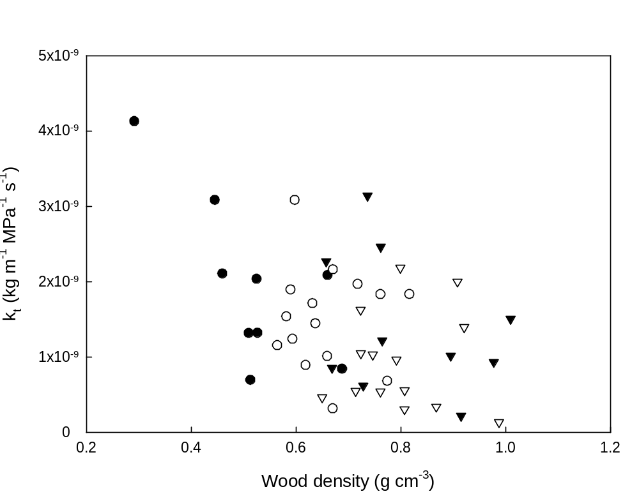
Figure 3
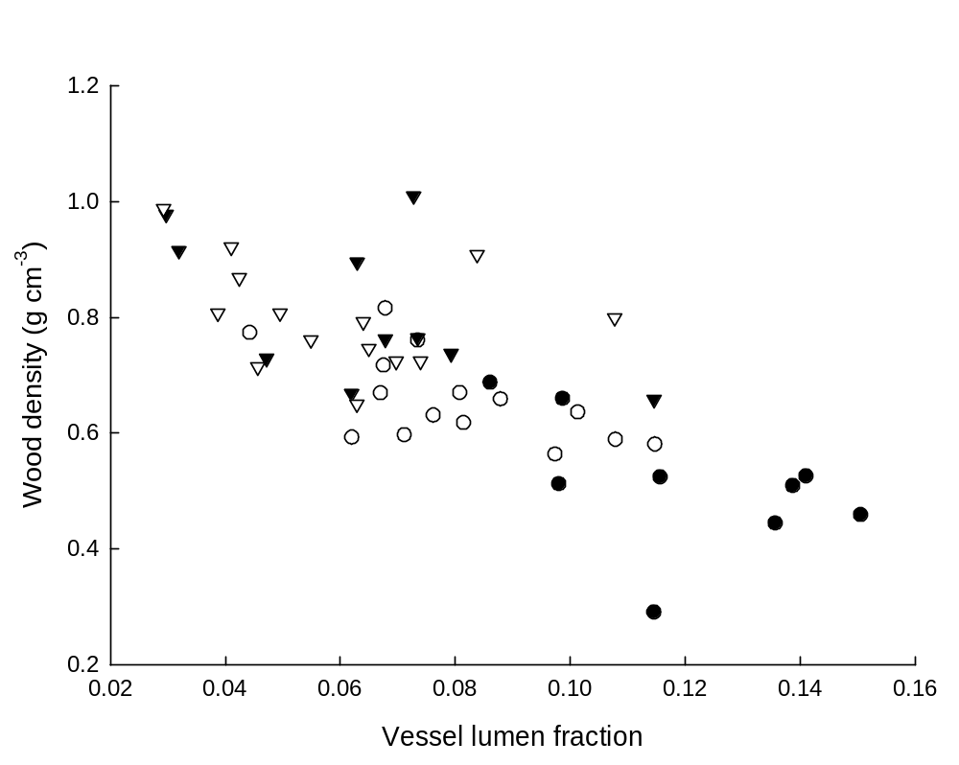
Figure 4

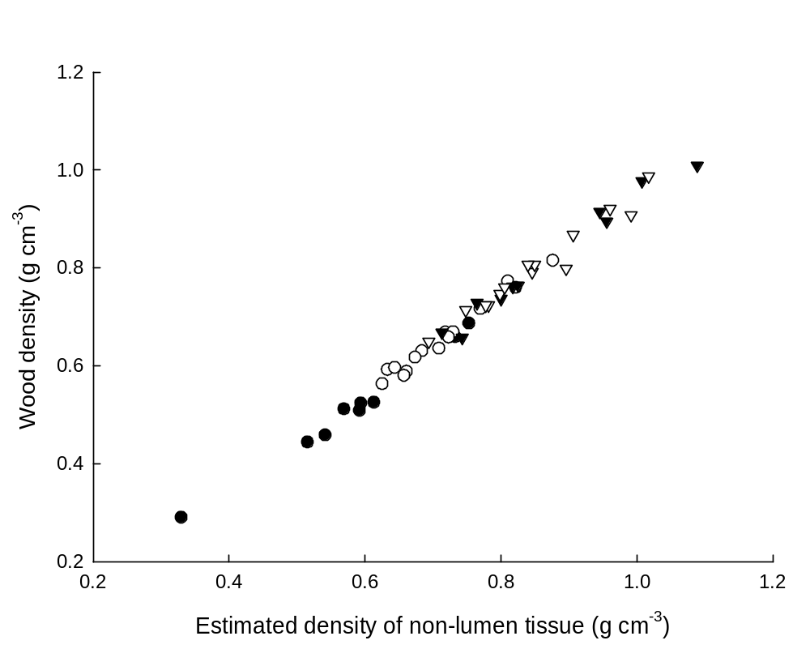
Figure 5
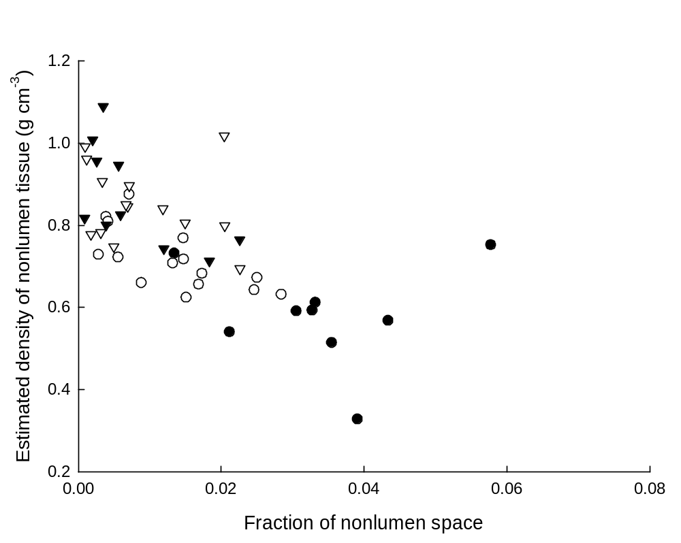
Figure 6
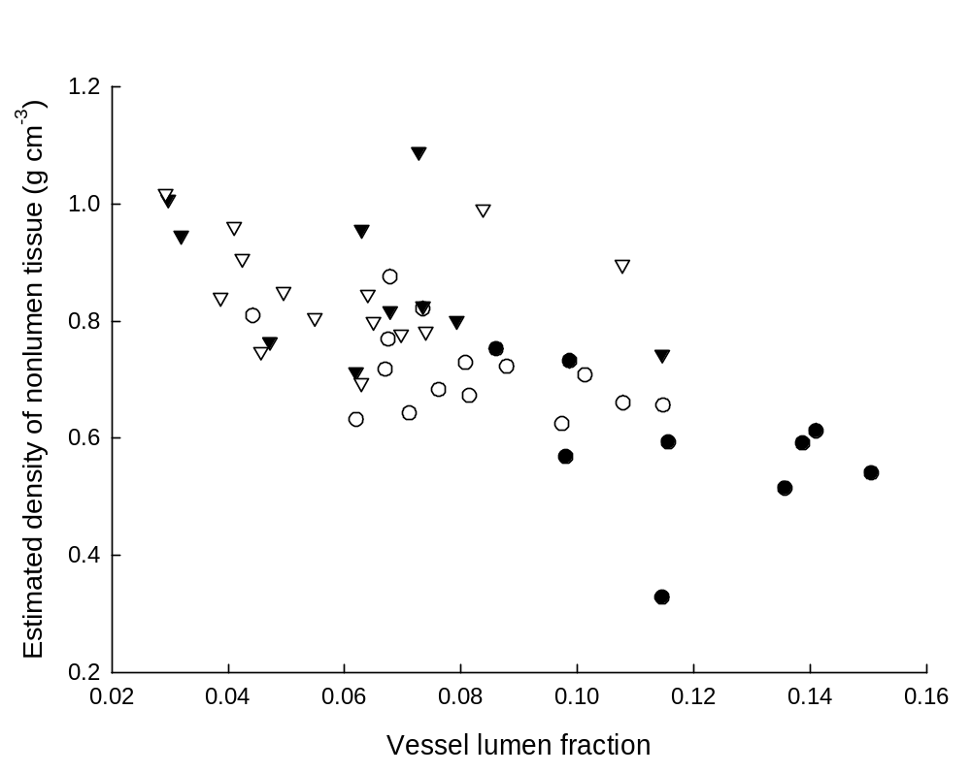
Figure 7
